Name: mosa ahmed mosa ibrahim

BN: 3

Sec:44

G:8

Topic : computer architecture

Github link: https://github.com/mosa-ahmed09/html-prject

Brief:

Computer architecture is a specification describing how hardware and software technologies interact to create a computer platform or system

Screen:

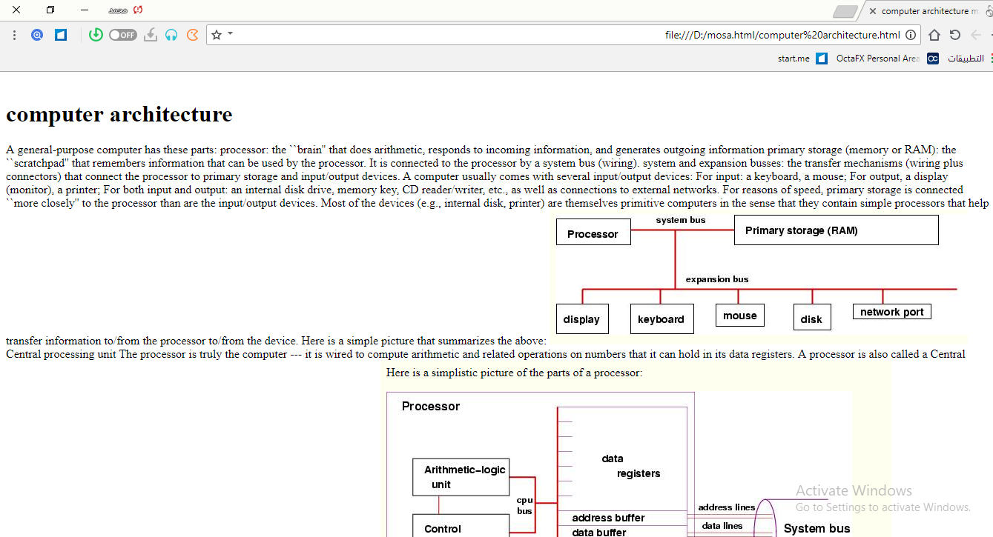

Screen:

